CASE STUDY
Answer the following questions based on the picture given below :
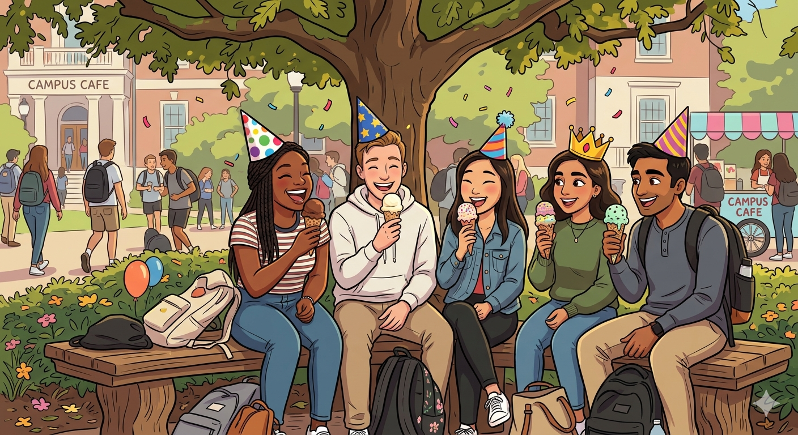
- Write the mirror image of the word “CAMPUS CAFE" .
- How many faces, edges and vertex does a birthday cap have ?
- Name any 2 objects from the above picture that
are 3D shapes.
- If the price of one ice-cream is ₹55, what is the cost of
14 ice-creams ?
- Mention the number of faces, edges and vertices of
the bench shown in the above image.

